CompTia A+
MODULE: Hardware and Components Basics: Understanding of Hardware and its components
Day 1: Overview of Hardware Components Theory
TASKS
1. Draw a labelled diagram of a desktop PC, clearly marking the motherboard, CPU, RAM, GPU, and both HDD and SSD storage components.
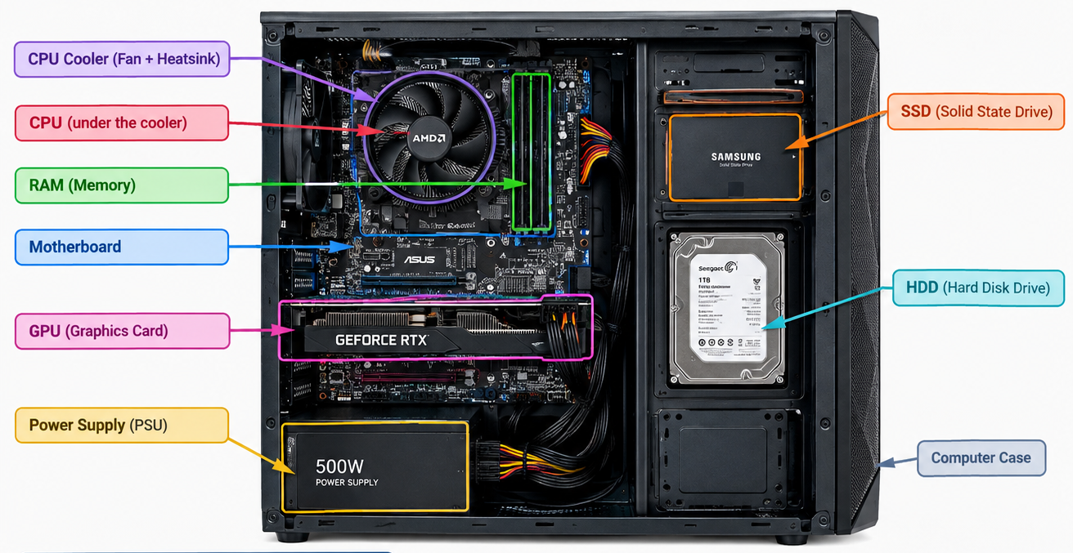

2.Create a comparison table showing the main differences between HDD and SSD storage in terms of speed, durability, and typical use cases. <br> <br> <em><strong>Hint:</strong> Think about which one is faster, which is more shock-resistant, and where you would usually find each type (laptop, gaming PC, etc.).</em>.
Feature | HDD (Hard Disk Drive) | SSD (Solid State Drive)
Speed | Slower | Much faster
Durability | Less durable; has moving parts | More durable; no moving parts
Shock Resistance | More sensitive to shocks and drops | More resistant to shocks and vibrations
Noise | Can make noise while operating | Silent
Typical Use | Desktop PCs, bulk storage, backups | Laptops, gaming PCs, modern computers
Cost | Usually cheaper per GB | Usually more expensive per GB
Best For | Large-capacity, low-cost storage. | Fast booting, gaming, apps, and everyday performance.

3.Write a short explanation (2-3 sentences each) describing the role of the CPU, RAM, and GPU in running a game like PUBG or Free Fire on a PC.
CPU (Central Processing Unit):
The CPU handles the game's main calculations, game logic, player movements, and system tasks. It helps the game run smoothly by processing instructions quickly.
RAM (Random Access Memory):
RAM temporarily stores the data and instructions that the game needs while running. More RAM helps the game run smoothly and reduces slowdowns when other applications are also open.
GPU (Graphics Processing Unit):
The GPU renders the game's graphics, including characters, environments, textures, and visual effects. A powerful GPU provides better graphics quality and higher, smoother frame rates.
4.Imagine you want to upgrade your PC to run the latest version of FIFA smoothly. List which hardware components you would consider upgrading and explain why for each.
Hardware Component | Why Upgrade It?
GPU (Graphics Card) | A powerful GPU improves graphics quality and provides smoother FPS during gameplay.
CPU (Processor) | A faster CPU helps process game physics, player movements, AI, and other game calculations efficiently.
RAM | Increasing RAM helps the game run smoothly and reduces lag when other applications are running in the background.
SSD | Installing the game on an SSD improves loading times and makes the overall system feel more responsive.
Power Supply (PSU) | If upgrading to a powerful GPU or CPU, a suitable PSU may be needed to provide enough stable power to the components.

